FAST FOURIER TRANSFORMS USING ALGOVISION
- Romita Pawar

Introduction:
The Fast Fourier Transform (FFT) is an algorithm that efficiently computes the Discrete Fourier Transform (DFT) of a sequence or its inverse. It transforms a signal from its original domain (commonly time or space) into a representation in the frequency domain and vice versa. The FFT is widely used across various fields like engineering, music, science, and mathematics.
Working:
- Decomposition: The DFT decomposes a sequence of values into components of different frequencies. The Fourier transform decomposes a waveform into a sum of sinusoids of different frequencies.
- Time-Domain to Frequency-Domain: The FFT converts time-domain data into frequency-domain information, which helps to analyze the spectral content of signals. By understanding the frequency content of a signal, key signal features, noise, and distortions can be identified and isolated.
- FFT Speed vs DFT: The FFT is an optimized algorithm for the implementation of the Discrete Fourier Transformation (DFT). A direct computation of the DFT requires O($N^{2}$) operations, while the FFT algorithm allows the same computation in O(N logN) operations, providing a significant speedup, especially for large datasets.
FFT Equation:
- The equation below represents the continuous-time Fourier transform:
$$F\left(ω\right)= \int_{-∞}^{∞}{f\left(x\right) } e^{-iωx}dx$$
Where:
  - F(ω) is the Fourier transform of the function f(x).
  - f(x) is a function of time.
  - e is the base of the natural logarithm.
  - i is the imaginary unit.
  - ω is the angular frequency

Feedback:
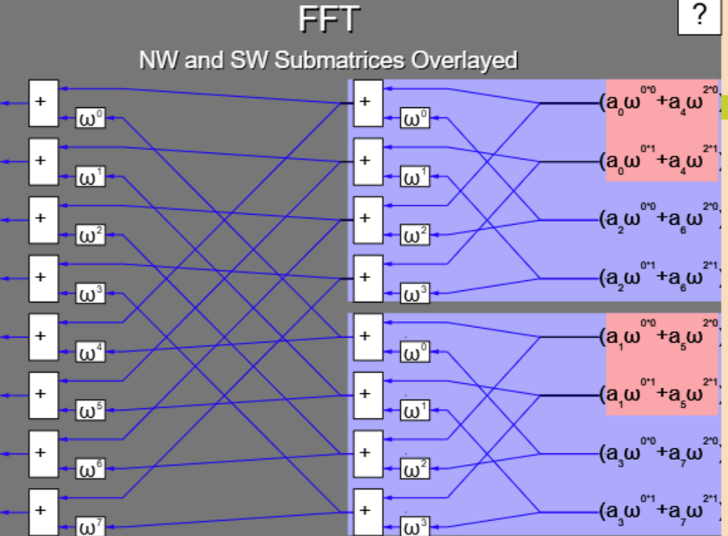

Signs in the should be alternative…. For $ω$0 it should be positive ‘+’ then for $ω$1 it takes negative sign ‘-‘.

Algovision does not include the DIT and DIF FFTs. These should also be added in the same respectively because these are not only a major part of FFT but also much easier to understand and one can quickly grasp these 2 as well if he/she gets through these visuals of FFT.

The whole process here as described below… with my example for DIT-FFT and DIF-FFT; for N = 8 and N = 4 respectively. Similarly, one can calculate for N=16 N=32 and N=64. As we go in the higher N values, the calculations goes much more harder and complex but one can get an in-depth knowledge and understanding at the same time.

Q. Compute DFT of x(n) = {1,2,3,4,5,6,7,8} using DIT-FFT Algorithm. Compare Computational Complexity of above algorithm with DFT.
Solution:

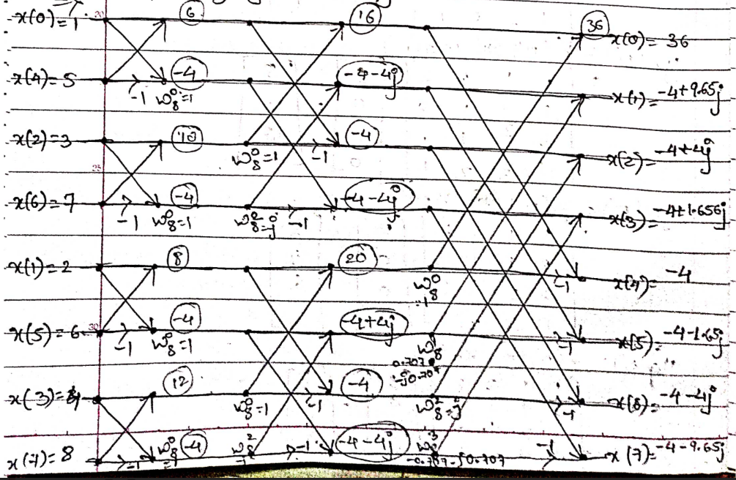
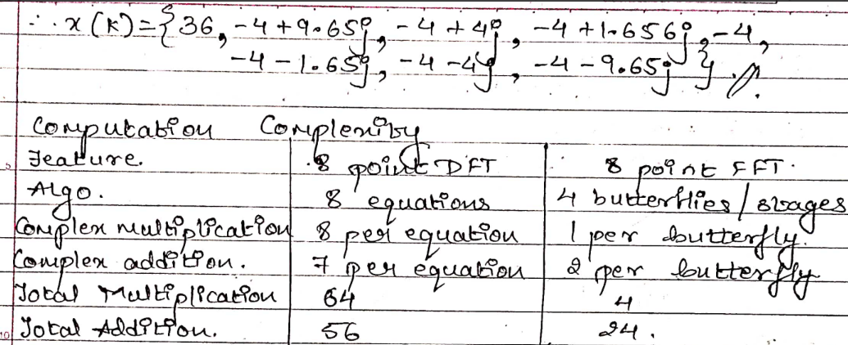
Similarly, here is an example for DIF FFT for N=4;

Q. If x(n) = {1,2,1,2} ; determine X[K] using DIF-FFT
Solution:
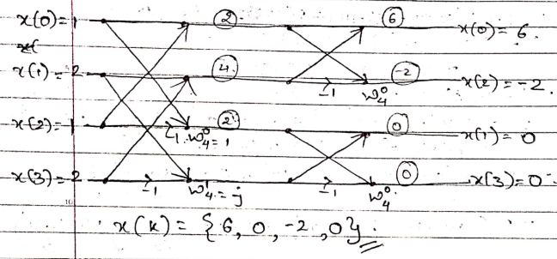

Also, In Initial Stage or Very 1st Step, The given x(k)/x(n) must be there. This will also make the Numerical much more self-understandable by itself, what is the value of N = 4/8/16/32.
Also, in the Final Stage/Step, The x(n)/x(k) = {_,_,_,_} should be added.

Conclusion:
The evaluation of Algovision’s Fast Fourier Transform visualizations reveals several areas of improvement, including in depth calculation visualization, initial and final presentation of answers/solutions, how to know what to find either DIF or DIT operations and adding of -j and much more as expressed by my 2 numerical solution examples. Implementing these suggestions would enhance the tool’s clarity and effectiveness, providing users with a more intuitive and comprehensive understanding of FFT.

